Global Specialty Steel, Wire Solutions
4135 West 126th Street, Alsip, IL 60803
July 20, 2026
REACH / SVHC Compliance Statement – EU Regulation EC 1907/2006, Annex XVII
To Our Customers,
Global Specialty Steel takes its obligations under the REACH Regulation (EC 1907/2006) seriously, and we periodically assess how it applies to our product line. Under the regulation, the items we supply fall within the definition of “articles,” meaning they do not fall under REACH's registration requirements.
As of the date of this letter, we have cross-checked our product line against the most recent SVHC Candidate List published by the European Chemicals Agency (ECHA) and confirmed that none of these substances are present in the materials we supply. This is further supported by our suppliers, who conduct independent, periodic testing on their materials to verify ongoing conformity with REACH requirements. The current Candidate List is available at https://echa.europa.eu/candidate-list-table. As the list is updated periodically by ECHA, we encourage customers to consult it directly for the most current information, and we will update this statement as needed to reflect any changes.
Please don’t hesitate to reach out if you need any additional documentation.
Best regards,
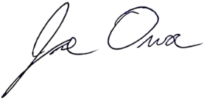
Joe Owoc
General Manager

